

**ONLINE SHOPPING**

**Software Design Document**

– Hanoi, September 2021 –

**Table of Contents**

I. Overview 3

1. Code Packages 3

2. Database Schema 3

II. Code Designs 4

1. <Feature/Function Name1> 4

a. Class Diagram 4

b. Class Specifications 4

c. Sequence Diagram(s) 4

d. Database queries 5

2. <Feature/Function Name2> 5

III. Database Tables 5

1. <Table name 1> 5

2. <Table name 2…> 5

# I. Overview

## Code Packages/Namespaces

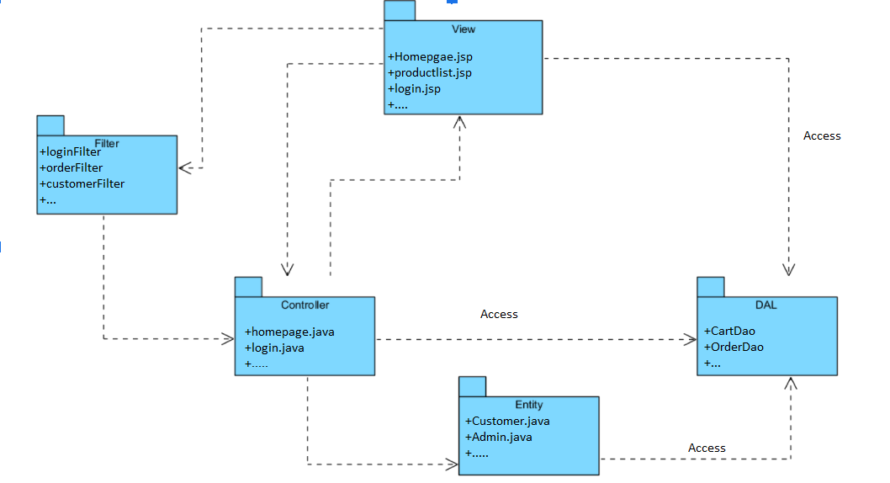

***Package descriptions & package class naming conventions***

|  |  |  |
| --- | --- | --- |
| **No** | **Package** | **Description** |
| *01* | *View(Web Pages)* | *Provide interaction with user ,GUI*  *Java Class Naming Convention* |
| *02* | *Controller* | *Control the data flow between view and model (DAO),Control the logic of the system*  *Java Class Naming Convention* |
| *03* | *DAL* | *Provide the connection to the Database, Extract data for the system* |
| *04* | *Filter* | *Control the redirection between Pages in View and from View to Controller*  *Java Class Naming Convention* |
| *05* | *Entity* | *Define the logic of data extracted from Database*  *Java Class Naming Convention* |
| *06* | *Util* | *Utility Function* |

# II. Code Designs

## 1. <Feature/Function Name1>

*[Provide the detailed design for the function <Feature/Function Name1>. It include Class Diagram, Class Specifications, and Sequence Diagram(s)]*

### a. Class Diagram

*[This part presents the class diagram for the relevant feature]*

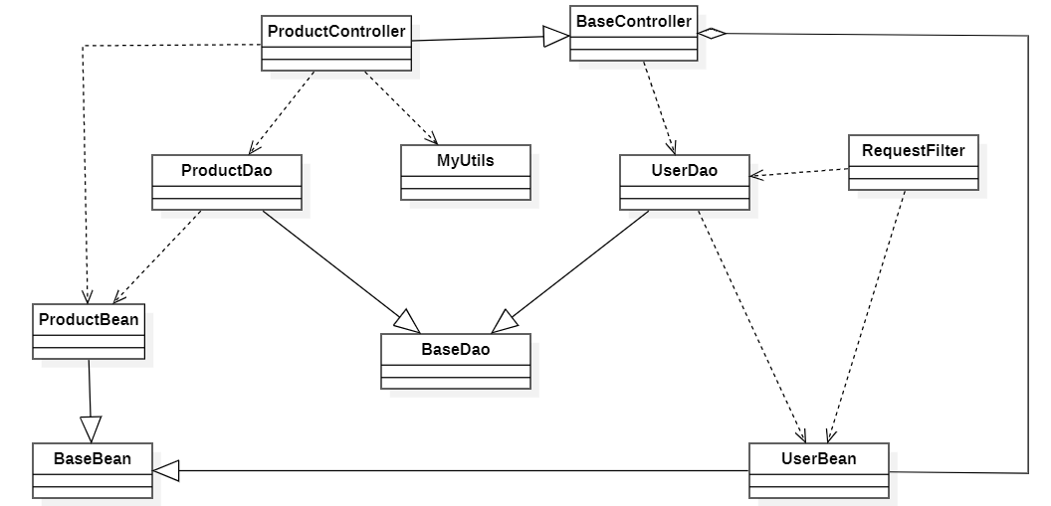

### b. Class Specifications

*[Provide the description for each class and the methods in each class, following the table format as below]*

#### XYZ Class

*[Provide the detailed description for the class methods]*

|  |  |  |
| --- | --- | --- |
| **No** | **Method** | **Description** |
| *01* | *<method name>* | *<Description of the method, including the inputs, outputs & internal method processing>* |
|  |  |  |

#### ABC Class

***Class Methods***

*[Provide the detailed description for the class methods]*

|  |  |  |
| --- | --- | --- |
| **No** | **Method** | **Description** |
| *01* | *<method name>* | *<Description of the method, including the inputs, outputs & internal method processing>* |
|  |  |  |

### c. Sequence Diagram(s)

*[Provide the sequence diagram(s) for the feature, see the sample below]*

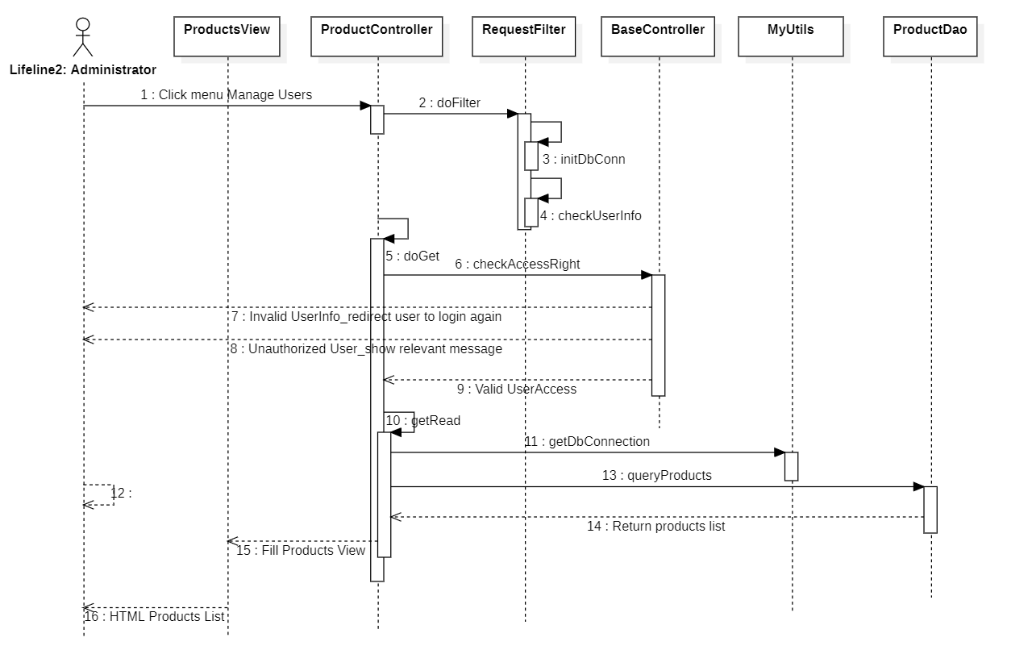

### d. Database queries

*[Provide the detailed SQL (select, insert, update...) which are used in implementing the function/screen]*

## 2. <Feature/Function Name2>

…

# III. Database Design

## 1. Database Schema

*[Provide the tables relationship like example below – following MySQL database naming convention]*

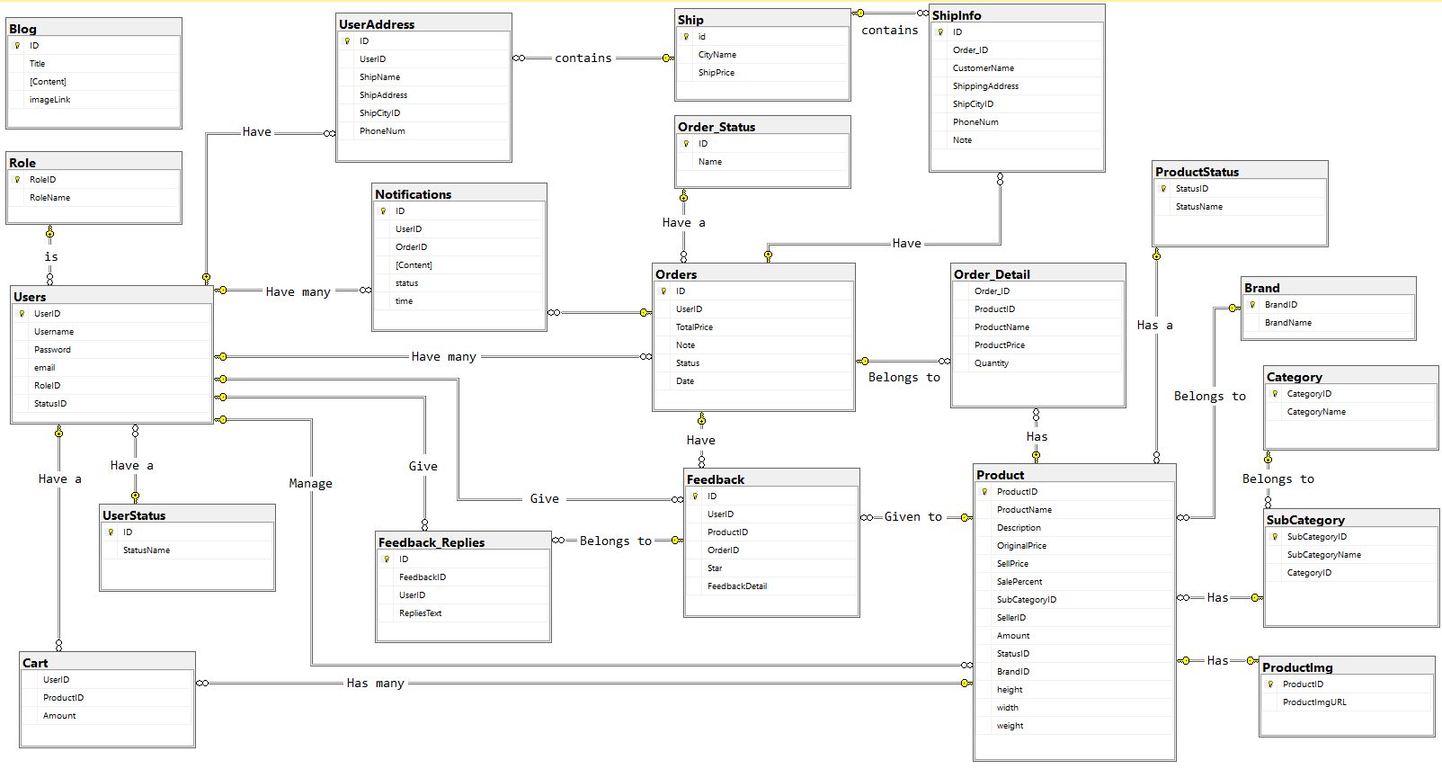

## 2. Table Description

|  |  |  |
| --- | --- | --- |
| **No** | **Table** | **Description** |
| *01* | *Blog* | *Blog content + image*  *- Primary keys: ID*  *- Foreign keys:* |
| *02* | *Role* | *Role of a user ( Admin,Marketing,Sale,Customer )*  *- Primary keys: RoleID*  *- Foreign keys:* |
| *03* | *UserStatus* | *Account activation status*  *- Primary keys: ID*  *- Foreign keys:* |
| *04* | *Ship* | *Shipping price for each city*  *- Primary keys: id*  *- Foreign keys:* |
| *05* | *Order_Detail* | *Detail of each product in order*  *- Primary keys:*  *- Foreign keys: OrderID, ProductID* |
| *06* | *UserAddress* | *Address for each user*  *- Primary keys:ID*  *- Foreign keys: UserID, ShipCityID* |
| *07* | *Users* | *Users*  *- Primary keys: UserID*  *- Foreign keys: RoleID,StatusID* |
| *08* | *Notification* | *Notification data*  *- Primary keys: ID*  *- Foreign keys: OrderID, UserID* |
| *09* | *ShipInfo* | *Shipping info for each order*  *- Primary keys: ID*  *- Foreign keys: Order_ID, ShipCityID* |
| *10* | *Order* | *Order data*  *- Primary keys: ID*  *- Foreign keys: UserID,Status* |
| *11* | *Feedback* | *Feedback of a product order*  *- Primary keys: ID*  *- Foreign keys: UserID,ProductID, OrderID* |
| *12* | *Feedback_Replies* | *Replies of feedbacks*  *- Primary keys: id*  *- Foreign keys: FeedbackID,UserID* |
| *13* | *Order_Status* | *Status of a order*  *- Primary keys: ID*  *- Foreign keys:* |
| *14* | *Product* | *Product Data*  *- Primary keys: ProductID*  *- Foreign keys: SubCategoryID,SellerID,StatusID,BrandID* |
| *15* | *Category* | *Category Data*  *- Primary keys: CategoryID*  *- Foreign keys:* |
| *16* | *SubCategory* | *Sub Category ID*  *- Primary keys: SubCategoryID*  *- Foreign keys: CategoryID* |
| *17* | *Productimg* | *Image of products*  *- Primary keys:*  *- Foreign keys: ProductID* |
| *18* | *ProductStatus* | *Status of a product*  *- Primary keys: StatusID*  *- Foreign keys: StatusName* |
| *19* | *Brand* | *Brand data*  *- Primary keys: BrandID*  *- Foreign keys:* |
| *20* | *Cart* | *Cart info for each user*  *- Primary keys: UserID*  *- Foreign keys: ProductID* |